**Background Summary - Backpack industry**

* 300 million industry with
* 3 main market segments – laptop, school and hiking backpacks
* 4 main players – tran-sport backpacks, youth packs, community backpack, and pro-packs
  + Competitor Analysis

|  |  |
| --- | --- |
| **Players** | **Competitive Advantages** |
| Tran-sport Backpacks | * Segment Focus: large **laptop** pack * Cost Advantage: company produces large volumes in its expensive legacy factories * Pricing Strategy: aims at a **mid-price** range * Market Share: **up to 50%** in some segments |
| Youth Packs | * Segment Focus: **kid**’s pack * Pricing Strategy: pricing in the **middle** of the field * Market: school pack segment + another segment (? rumor) |
| Community Backpack | * Cost Advantage: lean production facilities -> supply the market with a lower priced pack option * Pricing Strategy: reasonably priced (**low-price**) packs * Market Share: gain market share because of lower price |
| Pro-Packs | * Segment Focus: **Hiking** pack * Pricing Strategy: **Premium** brand * Market Share: **40-60% for hiking pack** + moving to kid and laptop segments |

**Case Analysis**

**Competitor (Tran-sport) Strategic Business Planning**

"We have identified the hiking pack segment as the primary focus for future growth. Transport is the biggest player in the overall pack market and well established in the laptop packs segment. We see an opportunity to improve our margins while still giving consumers a lower price than is currently offered in the hiking pack market. Starting today we are lowering the prices on our hiking packs by 10% in all channels."

Key takeaway

* Tran-sport wants to move to new segment – hiking pack
* Pricing strategy – give 10% discount

How Pro-Packs React – high level summary?

Current Pricing Strategy Comparison of 4 main players for 3 different products

|  |  |  |  |
| --- | --- | --- | --- |
| Players | Laptop Packs | School Packs | Hiking Packs |
| Tran-sport Backpacks | 70-80 | 47.5-52.5 | 145-155 |
| Youth Packs | 70-80 | 47.5-55 | 145-155 |
| Community Backpacks | 70-77.5 | 47.5-52.5 | 145-155 |
| Pro-Packs | 82.5 (11%) | 55 (12%) | 162.5 (48%) |

*here not specify pricing for different marketing channel; bracket is market share

Since now Tran-sport Backpacks would like to offer 10% discount for the hiking packs as a way to enter new market segment (previously they majorly focus on laptop packs). Therefore, the expected price of hiking packs that tran-sport backpacks will sell would be around $130-$140 which is around $30 maximum difference between what Pro-packs offer and this might affect customer purchasing decision when they are considering the hiking packs. The price war will have several impacts to existing market players: 1. Tran-sports might be able to gain some market share in the hiking packs due to the low-price strategies 2. Existing market players might react to this situation through either non price moves or play the price war game with tran-sports and each solution will have different impacts which will discuss in detail in the below.

How Pro-Packs current pricing for different products and channel

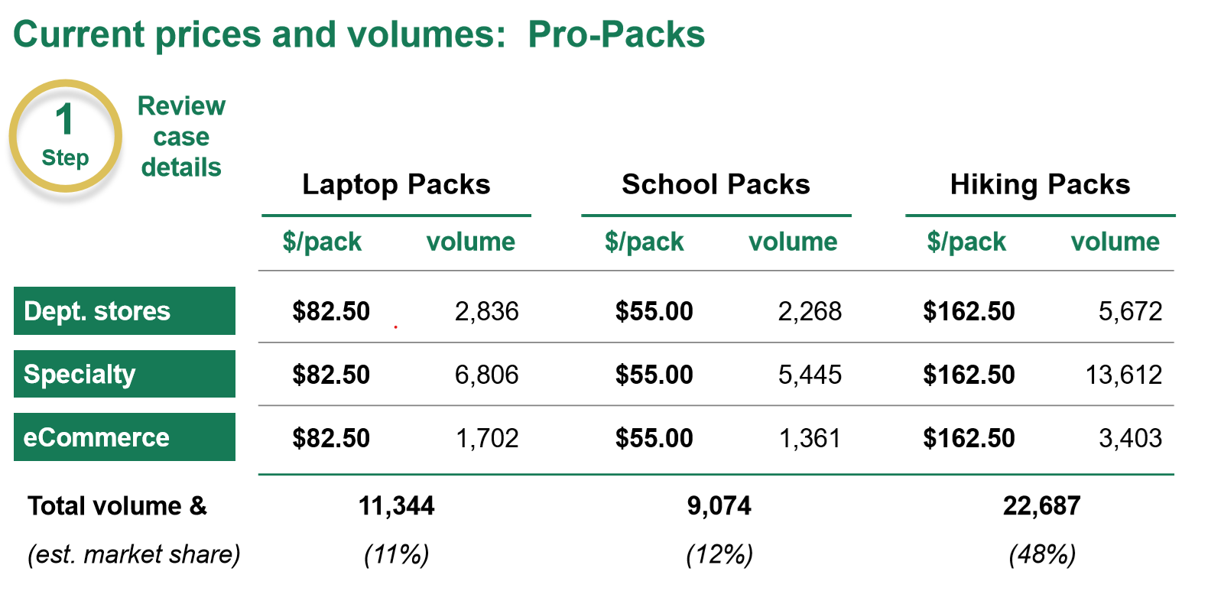

Pro-Packs price moves for the Laptop segment in each channel

Since the laptop packs segment have ~400k potential sold annually which is the highest sales among three segments. Since it’s a considerable large profit pool and opportunities, Pro-packs might consider to expand to this segment by having the strategy “attacking on the castle” to gain market share and now the castle here is “Tran-sport backpacks” since they have well-established market share in this segment. The attack the castle, we might start with doing some price strategy simulation.

|  |  |  |  |
| --- | --- | --- | --- |
|  | Pro-Packs laptop segment price | Tran-sport laptop segment price | Max Difference |
| No adjustment | $82.5 | 70-80 | 12.5 |
| 10% | $74.25 | 63-72 | 11.25 |
| 20% | $66 | 56-64 | 10 |
| 30% | $57.74 | 49-56 | 8 |
| 40% | $49.25 | 42-48 | 7.25 |

For now, Tran-sport backpacks only announces that they will reduce hiking packs price, so I would **assume that Tran-sport might not have any pricing changes on the laptop packs**. Also given Tran-sport is a castle in this segment, they might not want to reduce the product price for laptop packs unless there is another competitor setting the market price which is low enough to affect their market share.

|  |  |  |  |
| --- | --- | --- | --- |
|  | Pro-Packs laptop segment price | Tran-sport laptop segment price (price fixed no adjustment) | Max Difference |
| No adjustment | $82.5 | 70-80 | 12.5 |
| 10% | $74.25 | 70-80 | (5.75) |
| 20% | $66 | 70-80 | (14) |
| 30% | $57.74 | 70-80 | (22.26) |
| 40% | $49.25 | 70-80 | (30.75) |

Currently, Pro-Packs have 11% market share in laptop segment and we also know Tran-sport is the market leader in this segment. To expand our market share in this segment but at the same time we don’t want to make the price war so aggressive, then **10% discount for the laptop packs would be better for Pro-Packs**. By setting 10% discount, we are able to gain advantage over Tran-sport in terms of price so that customers who initially not consider our products might think our product is attractive now and buy it. Also, our product position is “premium” brand, it’s not appropriate to give too much discount since this might affects our brand image.

As for pricing for different channels, since I don’t have enough context about how different channels affect customer purchasing decisions as well as price elasticity in each channel, I would assume different channels might give customer same purchasing experience and therefore the pricing in each channel would be the same.

|  |  |  |
| --- | --- | --- |
| **Sales by Channel** | **Laptop packs** | **Rationale / Decision logic** |
| Online | 74.25 | Detail is mentioned above |
| Specialty | 74.25 |
| Department Store | 74.25 |
| Other price moves considered and logic | Detail is mentioned above | |

Pro-Packs price moves for the School Packs segment in each channel

School packs have ~300K annual sales which is the second highest sales among three segments. In this segment **Youth Packs is the main market leader** who price the products in the middle range, says not too expensive or too cheap. In this segment, every player seems to price similar price says $47-$55 and Pro-Packs makes up around 12% of market share. To further increase the market share but at the same time avoid having the price war, I would suggest we should **price at the range of 47-55** and if our purpose to increase the market share then I would set the price of $47. Setting lowest price in the price range doesn’t guarantee profit optimization but only can guarantee the market demand will increase and therefore the market share will increase.

Again, as for pricing for different channels, since I don’t have enough context about how different channels affect customer purchasing decisions as well as price elasticity in each channel, I would assume different channels might give customer same purchasing experience and therefore the pricing in each channel would be the same.

|  |  |  |
| --- | --- | --- |
| **Sales by Channel** | **School packs** | **Rationale / Decision logic** |
| Online | $47 | Detail is mentioned above |
| Specialty | $47 |
| Department Store | $47 |
| Other price moves considered and logic | Detail is mentioned above | |

Pro-Packs price moves for the Hiking Packs segment in each channel

When planning about how Pro-Packs react to the price reduction that Tran-sport backpacks has, this is especially important for Pro-Packs since Pro-Packs is the market leader in this segment which takes up around 48% of total market share. Also, since Pro-Packs is positioning as “premium” outdoor accessories brand, the pricing strategy will affect not only the market share that they have in this segment but also their branding. Even though lowering too much to fight the price war for one time only, Pro-Packs might damage their brand image forever. People might think them not as “premium” as before.

So now, Tran-sports decides to lower 10% of the price for its hiking packs. The new price of the hiking packs would be 130.5-139.5 (original 145-155). And our hiking packs price is 162.5. Since we don’t have customer price elasticity data and also the conjoint analysis data, it’s not easier to measure how much exactly this price reduction will affect our market share. If market share reduces a lot because of their pricing strategy, I think Pro-Packs definitely should follow their pricing strategy to at least keep their market share. However, if Pro-Packs brand is famous enough and their brand image is good enough, then they should not afraid that this price war will affect their market share a lot.

|  |  |  |
| --- | --- | --- |
| **Sales by Channel** | **Laptop packs** | **Rationale / Decision logic** |
| Online | $145.8 (10% reduction)  $ 162.5 | If competitor’s price reduction dramatically affects their market share, they need to follow their strategies. But if not, then can keep the same price. |
| Specialty | $145.8 (10% reduction)  $ 162.5 |
| Department Store | $145.8 (10% reduction)  $ 162.5 |
| Other price moves considered and logic | Detail is mentioned above | |